Investigation OF CYCLE TIME BEHAVIOR IN ROBOTIC FACE GRINDING PROCESS

Kedar Joshi, Shreyes N. Melkote

George W. Woodruff School of Mechanical Engineering

Georgia Institute of Technology

Atlanta, GA 30332-0405

Matt Anderson, Rahul Chaudhari

The Timken Company

Canton, OH

**Abstract**

Production of bearing rings involves face grinding of the ring faces on highly specialized and dedicated precision grinding machine tools. Articulated arm industrial robots with six degree-of-freedom (6-dof) are less expensive and are more versatile compared to precision grinding machines, since they can be readily reconfigured for a variety of production tasks. However, the compliance of such robots poses a challenge in high precision operations, particularly as it relates to the overall cycle time of the process. This paper presents an analysis of the effects of robot compliance and grinding process parameters on the cycle time of a robotic face grinding process. Specifically, a process model for the robot-workpiece interaction and face grinding process cycle time is developed. This model is used in conjunction with robotic face grinding experiments to analyze the behavior of the face grinding process cycle. The results show that for a given robot stiffness, minimizing the face grinding cycle time requires the process to be operated at the highest achievable wheel speed and infeed rate with a wheel of higher hardness.

# Introduction

Face grinding of industrial bearing rings is usually carried out using specialized high precision grinding machines that are characterized by high capital cost and high setup times [1]. In contrast, articulated arm serial link industrial robots are less expensive, have high reliability, generally require less workspace, and can be readily reconfigured for a variety of production tasks. While industrial robots are widely used for lower accuracy operations such as welding, painting, and deburring, their use in high accuracy material removal operations such as precision grinding is limited [2, 3, 4, 5].

A major reason for the limited use of articulated arm industrial robots in high accuracy precision grinding operations is their low static stiffness [6, 7, 8, 9] compared to a precision grinding machine. Elastic deflections of the robot joints and links in the presence of grinding forces influence not only the accuracy of the grinding operation but also the grinding process cycle time. Since grinding cycle time is an important productivity metric, a process model is required to analyze its dependence on the grinding process and machine parameters.

Grinding is an important finishing process with broad industrial application. Face grinding is a surface finishing method for producing high precision planar surfaces such as the end faces of bearing rings, connecting rods, and piston rings [10]. The face grinding process involves contact between the face of a workpiece (e.g., bearing ring) and the grinding wheel as shown schematically in Figure 1.

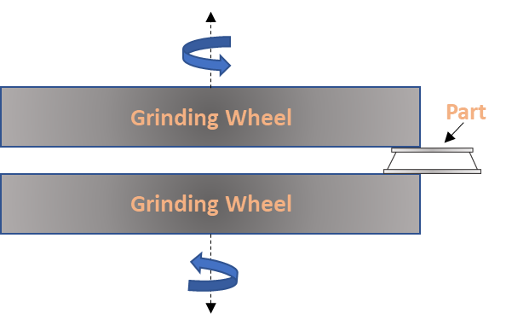

Figure : Face grinding operation schematic.

Grinding process performance is intimately affected by the workpiece material properties, grinding wheel properties, and machine stiffness. In the first of a series of pioneering papers, Hahn and Lindsay [11] established empirical relationships between the process forces and material removal rate in a cylindrical grinding process. In a second paper [12], they discussed wheel wear characteristics and the wear ratio in cylindrical grinding. Lindsay [13] and Hahn and Lindsay [14] derived an empirical relationship between the material removal rate and normal grinding force in cylindrical grinding, and also analyzed the effect of wheel dressing parameters on the surface finish and workpiece surface profile. The material removal rate was found to be directly proportional to the normal grinding force. The constant of proportionality was defined as the material removal parameter. Kannappan and Malkin [15] found that the specific cutting and plowing energies in surface grinding decrease with increase in table speed and feed rate, and the specific chip forming energy is independent of both. The wear flat area was found to be larger at higher table speeds and feed rates. Lal [16, 17] studied the mechanics of chip formation and wheel wear in vertical surface grinding, where the wheel axis is tilted by a small amount such that only the grains at the leading edge of the wheel make contact with the workpiece during grinding. His work showed that the normal grinding force increases with table speed, depth of cut, and material removal rate. The specific cutting energy was found to decrease with material removal rate.

In order to understand the role of machine deflections on the grinding process cycle time, Malkin [18] presented a continuous infeed analysis of the grinding cycle time while considering the effects of machine stiffness, work speed, and grinding wheel grade.

Many robotic grinding applications involve grinding using abrasive belts, which involve feeding of a workpiece held in the end effector of the robot arm into a moving abrasive belt. Wang et al. [19] analyzed the effect of depth of cut on wheel deformation in robotic belt grinding due to belt tension. They utilized an analytical local stress and material removal model, which was validated through simulation using the finite element method (FEM) and belt grinding tests. Zhu et al. [20] found that the specific cutting energy in robotic belt grinding is independent of the ideal depth of cut but is dependent on the depth of grain penetration. They also found that the sliding specific energy is dominant compared to ploughing and chip formation energies. Ren et al. [21] developed simulation models for robotic belt grinding to estimate the material removal rate. It is possible to utilize their work to improve path planning and reduce geometrical inaccuracy. Yixu et al. [22] tracked the time varying responses such as belt wear in robotic belt grinding via statistical machine learning to enable accurate prediction of the material removal rate. To mitigate the problem of poor accuracy in robotic belt grinding, Xie et al. [23] designed a fuzzy controller to achieve a force-position hybrid control to improve positional accuracy. Work by Sun et al. [24] focused on in-process path calibration using a linear displacement sensor. The pose of the displacement sensor was calibrated using a spherical surface and the calibrated sensor was used to calibrate the relative pose of the robot tool frame. A force control strategy was then implemented to minimize the error between the commanded and real positions. The robotic grinding review by Zhu et al. [25] focuses on understanding different strategies that have been developed till date on allowance control, contact force control and surface integrity of machined surface. Their review has highlighted that despite the advantages associated with robots in terms of flexibility and cost, there are gaps in machining accuracy and surface quality due to high coupling between the grinding performance and robot configuration, compared to the CNC machines. Latifinavid et al. [26] devised a grinding force model to implement a real-time tool deflection compensation algorithm. Although they account for the tool deflection, their work uses a parallel hexapod robot which has a much higher compliance compared to a 6-axis robot manipulator.

Similarly, Huang et al. [27] focused on controlling and optimizing the path of the belt grinder, which was attached to the end effector of a 6-dof robot, to compensate for belt wear and to control the pressure between the wheel and workpiece surfaces.

It can be deduced from the literature survey that although significant research has been done in understanding relevant aspects of the grinding process and robotic belt grinding, there is little work on robotic face grinding. Specifically, knowledge of the effects of robot compliance and the face grinding process parameters on process performance measures such as grinding process cycle time are required to successfully implement an effective robotic face grinding solution for high precision components such as bearing rings. Considering these issues, this paper focuses on the following aspects of the robotic face grinding process: 1) modeling of the effect of robot compliance on face grinding process cycle time, and 2) identification of robotic face grinding process conditions necessary to optimize the face grinding process cycle time.

The paper is organized as follows. A robotic face grinding process model that relates the face grinding process parameters and robot Cartesian stiffness to the overall cycle time is first presented. Next, the experimental robotic face grinding setup for validating the model is described. This is followed by identification of the process parameters necessary to minimize the face grinding process cycle time. Finally, key conclusions of the work are presented, and possible future extensions of the work are discussed.

# Robotic Face Grinding Process Model

A face grinding process model that relates the grinding process cycle time to the grinding process parameters and robot Cartesian stiffness is derived in this section. The model is required to analyze the effects of grinding process parameters such as the infeed rate, wheel-work contact area, wheel speed, wheel properties, and robot stiffness on the grinding cycle time.

## Process Configuration

As shown in Figure 2, the bearing ring is held in a counter rotating chuck mounted to the robot end effector, which is fed into the periphery of the grinding wheel surface where the wheel speed is maximum. The face grinding process involves contact between the rotating face of the bearing ring and the rotating grinding wheel as depicted in the figure.

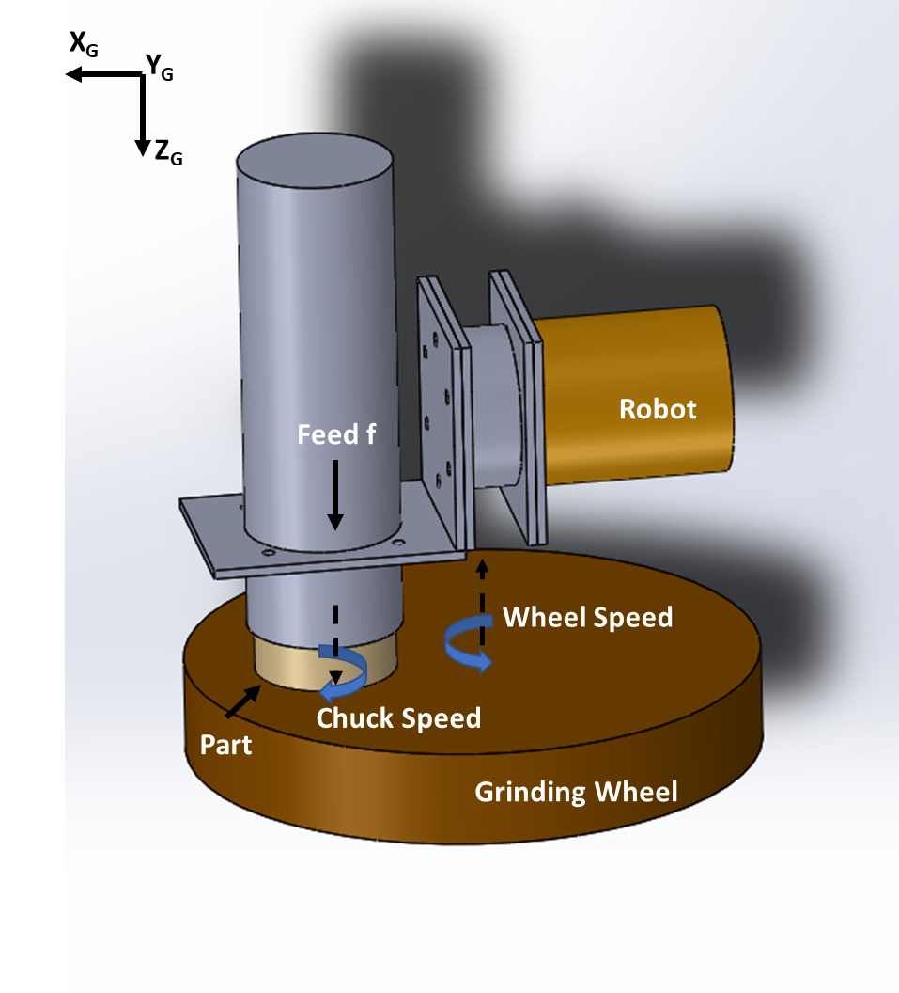

Figure : Process configuration.

During the face grinding operation, the actual infeed of the robot does not match the commanded infeed. This is because the robot elastically deforms under the influence of the time-varying normal forces generated at the wheel-work interface. These deflections of the robot end effector in turn affect the material removal rate and the overall process cycle time.

## Material Removal Rate

Denoting the rate at which the part feeds into the wheel (infeed) as *f* and the surface contact area of the ring as *A*, the material removal rate, *MRR*, can then be written as:

|  |  |  |
| --- | --- | --- |
|  | $$MRR=f A$$ | (1) |

Hahn and Lindsay [14] have empirically shown that the MRR per unit width in cylindrical plunge grinding is linearly proportional to the normal force intensity, which is the normal force per unit width of wheel-part contact. They termed the constant of proportionality as the material removal parameter, $λ_{w}$. Assuming a similar relationship holds in face grinding, the relationship between the *MRR* and the normal grinding force, $F_{n}$, can be written as,

|  |  |  |
| --- | --- | --- |
|  | $$f A=λ_{w} F_{n}$$ | (2) |

As discussed later, the material removal parameter $λ_{w}$ depends on the process and wheel parameters such as wheel speed, work speed, cooling conditions, wheel hardness, etc. Another important result of Hahn and Lindsay [14] relevant to face grinding process modeling is that $λ_{w}$ is directly proportional to the relative speed of the workpiece with respect to the grinding wheel. However, since the wheel speed is generally much larger than the work speed, it is approximated by the wheel speed. The next section analyzes the face grinding process cycle to derive a relationship for the process cycle time as a function of the face grinding process parameters and the robot stiffness.

## Robotic Face Grinding Process Cycle

As shown schematically in Figure 3, the face grinding cycle consists of an initial roughing phase (*t < t1*)at a constant commanded infeed followed by a spark-out phase (*t > t1*) with no infeed.



Figure : Robotic face grinding process cycle.

In the figure, the difference between the commanded infeed and the actual infeed is a result of the static deflection of the robot end effector due to the normal grinding force produced at the wheel-part contact. If we assume that the robot Cartesian stiffness at the end effector in the infeed direction for a given robot configuration is denoted by *KR*, the static normal force acting on the robot can be written as,

|  |  |  |
| --- | --- | --- |
|  | $$F_{n}=K_{R} \left(x_{com}-x_{act}\right)$$ | (3) |

where *xcom* and *xact* are the commanded and the actual robot end effector positions at a given time instant. Note that we assume the wheel part-contact is rigid. When the part initially contacts the rigid wheel, the robot deflects elastically due the normal grinding force. Although *xact* is defined as the actual robot end effector position, it is also equal to the height of material removed from the part after initiation of the grinding cycle. Substituting Eq. 3 into Eq. 4 gives,

|  |  |  |
| --- | --- | --- |
|  | $$λ_{w} K_{R} \left(x_{com}-x_{act}\right)=f A$$ | (4) |

But since the infeed rate, *f*, is the time derivative of the actual robot position or the rate at which the height of the ring is reduced, we can rewrite Eq. 4 as,

|  |  |  |
| --- | --- | --- |
|  | $$λ_{w} K_{R} \left(x_{com}-x_{act}\right)= {\dot{x}}_{act} A$$ | (5) |

The grinding cycle in Figure 3 consists of two parts. The first part has a constant infeed and while the second part has zero infeed and represents the spark-out phase of the grinding cycle. Denoting the initial constant infeed as *U1*, which is the slope of the commanded infeed motion, we can write,

|  |  |  |
| --- | --- | --- |
|  | $$x_{com}= U_{1} t$$ | (6) |

|  |  |  |
| --- | --- | --- |
|  |  | (7) |

Solving for *xact* yields the robot’s instantaneous position and the actual height of material removed as a function of time during the first part of the grinding cycle as,

|  |  |  |
| --- | --- | --- |
|  | $$x_{act}= U_{1}(t+τ e^{-\frac{t}{τ}}-τ)$$ | (8) |

where,

|  |  |  |
| --- | --- | --- |
|  | $$τ=\frac{A}{λ_{w} K_{R}}$$ | (9) |

Equation 8 describes the path of the robot in the first part of the grinding cycle i.e. for *t < t1*. The infeed rate is constant from *t = 0* to *t = t1* following which the commanded infeed is set to zero during the spark-out phase.

The commanded robot position during the spark-out phase (*t > t1*) can be written as,

|  |  |  |
| --- | --- | --- |
|  | $$x_{com}= U_{1} t_{1}$$ | (10) |

The initial condition for the spark-out phase can be written as,

|  |  |  |
| --- | --- | --- |
|  | $$x_{act }\left(t_{1}\right)= U_{1}\left(t_{1}-τ e^{-\frac{t_{1}}{τ}}+τ\right)$$ | (11) |

Integrating the above initial condition into Eq. 10 gives the actual robot end effector position during the spark-out phase of the grinding cycle as,

|  |  |  |
| --- | --- | --- |
|  | $$x_{act }= U_{1}t_{1}-U_{1}τe^{-\frac{t-t_{1}}{τ}}(1-e^{-\frac{t_{1}}{τ}})$$ | (12) |

The constant $τ$ represents the time constant of the system. It also represents the lag in a first order system, in this case between the actual and commanded positions of the robot end effector. Using the two equations that describe robot’s actual trajectory (Eq. 8 and Eq. 12), the equation for the face grinding process cycle time (*T*) can be derived as a function of the process parameters as follows,

|  |  |  |
| --- | --- | --- |
|  | $$T= t_{1}-τ\ln{\frac{Δr_{2}}{U_{1}τ(1-e^{-\frac{t_{1}}{τ}})}}$$ | (13) |

Where $Δr_{2}$ in Eq. 13 denotes the width tolerance of the part. The spark-out phase is deemed completed when the actual part width is within the tolerance limit, i.e. $Δr_{2}$ is equal to the width tolerance of the part, which is 50 μm in this work.

The above model is calibrated using robotic face grinding experiments and then used to estimate the material removal rate and overall process cycle time. In addition, the effects of the grinding process conditions on cycle time are analyzed.

# Experimental Details

The experimental setup consists of a 6-axis articulated arm Staubli RX 170 industrial robot with controller, end-effector mounting for workpiece holding, force and laser sensors for measurement, grinding spindle, workpiece spindle, grinding coolant supply system, and the chiller unit for spindle. Figures 4a and 4b show close-up views of the experimental setup.

The spindle used for the grinding wheel is a Weiss GMBH 175369 spindle controlled by a Siemens 611 U controller. An L-bracket is used to hold the motorized rotary chuck, which holds and rotates the workpiece, on the robot end effector as shown in Figure 4a.. The six-axis force/torque sensor (ATI Omega 85) is sandwiched between the L-bracket and the robot end effector.

To measure the displacement of the end effector relative to the grinding wheel surface during face grinding, a single axis laser displacement sensor (Keyence LK-G3000) was installed on the L-bracket with the laser directly pointing towards the wheel surface, as shown in 4b.

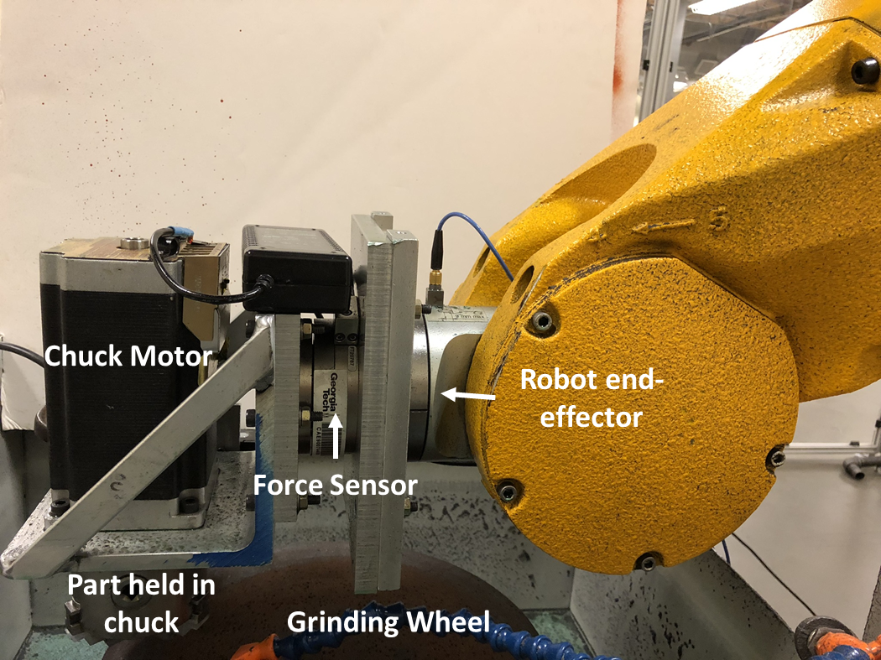 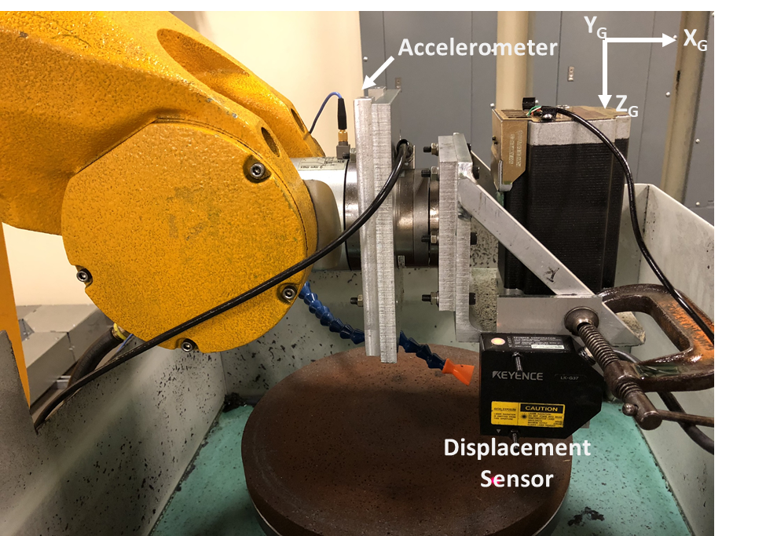

Figure 4: (a) Close-up view of test setup, (b) Laser displacement sensor for measurement of actual robot infeed during grinding.

A fixed configuration of the robot was chosen for all experiments described here. Two-wheel types differing in their hardness grades were selected for investigation. One was a soft wheel with a hardness grade G while the second wheel was of a harder grade I. The range of wheel speeds were chosen based on safety considerations since the grinding wheel spindle is not fully enclosed. The wheel speed was varied from 1000 to 2600 rpm in increments of 400 rpm. The workpiece rotation speed was set to 360 rpm. The robot infeed rate was varied from 10 μm/s to 30 μm/s in steps of 10 μm/s. The maximum infeed rate was limited by the maximum axial force that the rotary chuck holding the bearing ring was designed to withstand (~70N). Preliminary tests showed that the axial force limit of the rotary chuck was exceeded at infeed rates larger than 35 μm/s. The spark-out phase, and hence the grinding cycle, was deemed to be complete when the normal grinding force magnitude fell below 5 N at which point the robot end-effector holding the bearing ring was retracted from the grinding wheel surface. The analog signals measured by the laser displacement sensor and the force/torque sensor were sampled at 1000 Hz. A moving window average of the force data (window size of 0.003 seconds) was used to analyze the quasi-static behavior of the normal force signal during the face grinding cycle.

The robot Cartesian stiffness *KR* was determined by comparing the measured normal force with the force magnitude calculated using Eq. 3. Note that this equation permits calculation of the expected normal force profile as a function of the instantaneous displacement of the robot end-effector as it is fed into the grinding wheel. This is because the difference between the commanded infeed rate and the actual infeed rate gives rise to the normal force. The average value of *KR* (1.45 x 105 N/m) was used as the static Cartesian robot stiffness to estimate the grinding cycle process parameters. The material removal parameter (λw) was estimated from the best fit of the theoretical curves (Eqs. 8 and 12) to the measured displacement curves. The face grinding cycle time was calculated from Eq. 13.

Table 1 lists the set of experimental conditions selected to analyze the effect of the face grinding process parameters.

Table : Robotic face grinding experimental parameters.

|  |  |
| --- | --- |
| Ring material | Hardened Chrome Steel |
| Ring dimensions | 50 mm bore dia/ 60 mm OD  20 mm width |
| Coolant type | Trim Sol cutting fluid |
| Grinding wheel grades | G and I |
| Wheel rotation speed (RPM) | 1000, 1400. 1800, 2200, 2600 |
| Part rotation speed (RPM) | 360 ± 15 (5%) |
| Robot infeed rate (μm/s) | 10, 20, 30 |

The desired amount of bearing ring width to be ground in each test was 1. The robot controller was programmed to feed the bearing ring into the grinding wheel along a ramp input corresponding to the nominal travel distance required to achieve the desired width reduction followed by a spark-out phase. The spark-out phase removes material not removed during the ramp input phase because of elastic deformation of the system. Figures 5 and 6 show representative displacement and normal force measurements obtained at two different wheel speeds. It can be seen from the measured laser displacement signal that the system behaves like a first order system in that a ramp input produces a steady state after a fixed lag, which represents the time constant of the system. The time constant affects both the infeed (roughing) and the spark out (finishing) phases of the face grinding cycle. The difference between the commanded infeed profile (dashed curve) and the actual infeed profile (dot-dashed red curve or fitted solid green curve) represents the elastic deformation of the robotic system including the end-effector. Since the robot Cartesian stiffness is treated as a linear spring, the normal force in Eq. 3 is what the force sensor measures.

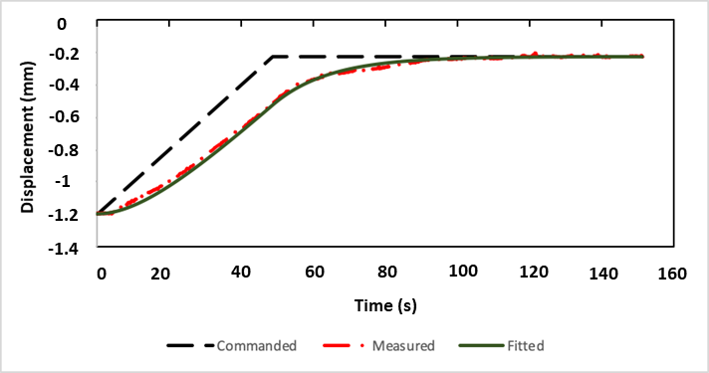

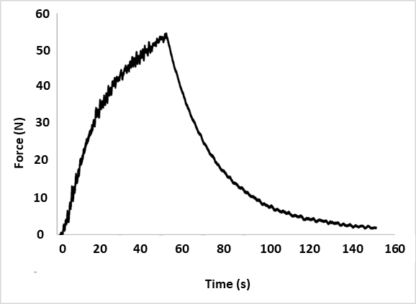

Figure 6: Robot end effector displacement and normal force plots for feed = 20 μm/s, wheel speed = 1000 rpm, workpiece speed = 360 rpm, wheel grade = I.

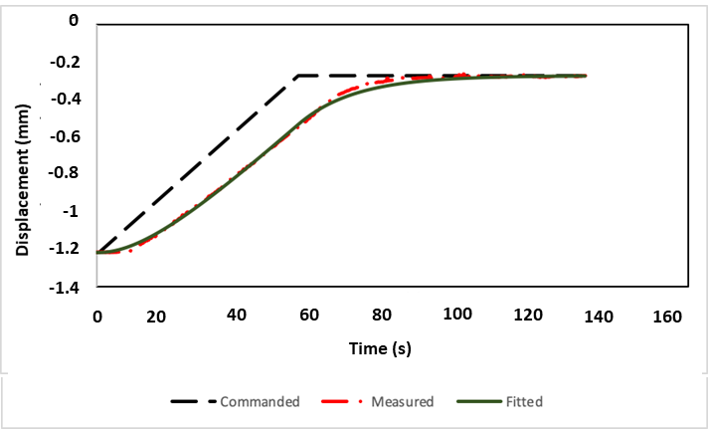

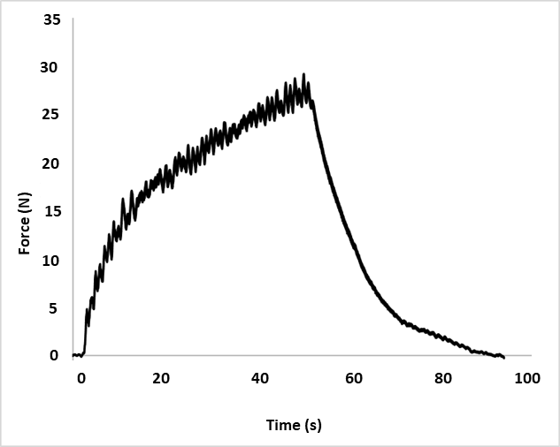

Figure 4: Robot end effector displacement and normal force plots for feed = 20 μm/s, wheel speed = 2600 rpm, workpiece speed = 360 rpm, wheel grade = I.

# Results and Discussion

The following parameters are derived from the experimental data and the effects of face grinding process conditions on these parameters are analyzed: i) Material removal parameter $λ_{w}$, ii) System time constant $τ$, iii) Total cycle time *T*.

The fitted robot displacement profiles in Figures 6 and 7 are obtained using values of the material removal parameter that best fit the theoretical model (Eqs. 8 and 12) to the measured displacement data. In each case R2 values greater than 0.98 were obtained.

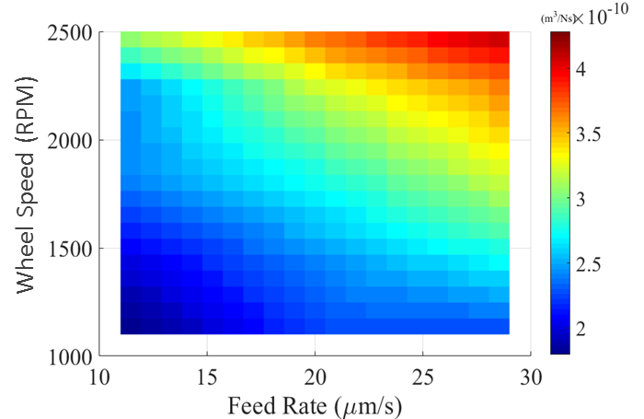

Figure 8: Material Removal Parameter for different infeed rates and wheel speeds.

As seen in Figure 8, the material removal parameter increases with the wheel speed and infeed rate. These trends are similar to those reported by Hahn and Lindsay [14] in the case of cylindrical plunge grinding. The material removal parameter values corresponding to a subset of the measured data were used to derive an empirical model of the material removal parameter. Specifically, the material removal parameter values for robot infeed rates of 10 and 30 μm/s and wheel rotation speeds of 1000 to 2600 rpm for wheel grades G and I determined from the fitted displacement curves were utilized to fit the empirical model as follows,

|  |  |  |
| --- | --- | --- |
|  | $$λ_{w}=p_{00}+p_{01}f+p_{02}Ω$$ | (17) |

where $f$ is the infeed rate in μm/s and $Ω$ is wheel rotation speed in RPM. The values of the model coefficients determined from data fitting are listed in Table 2 for the two wheel grades along with the corresponding R2 values.

Table : Material removal parameter model coefficients.

|  |  |  |  |  |
| --- | --- | --- | --- | --- |
| **Wheel Grade** |  |  |  | **R2** |
| G | 1.729 | 0.279 | 1.799 | 0.93 |
| I | -2.901 | 4.657 | 1.218 | 0.94 |

Using these equations, the material removal parameter values at an infeed rate of 20 μm/s and wheel rotation speeds ranging from 1000 to 2600 rpm were predicted for both wheel grades. The measured and predicted values for these cases are plotted in Figures 9 and 10. The measured values fit the predicted values with an R2 of 0.97 and 0.94 for wheel grade G and I, respectively. The most likely reason for the differences between the predicted and measured values is the parabolic nature of the material removal parameter with respect to the wheel speed. This can also be observed in the experimental study of Hahn and Lindsay [14]. The parabolic nature is evident in the data measured data for both types of grinding wheel. The predicted values seem to better fit the measured data points for lower and higher wheel speeds for wheel grades G and I respectively. The prediction can be improved by deriving a parabolic nature of the material removal parameter relationship with respect to wheel speed. But for practical purposes, the error due to a linear relationship is within acceptable limits.

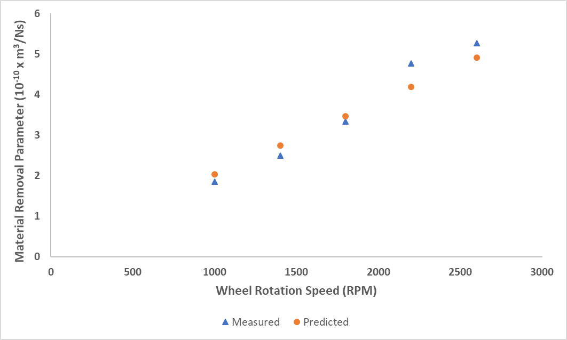

Figure 9: Comparison of measured and predicted material removal parameter values for infeed rate = 20 μm/s, wheel grade = G.

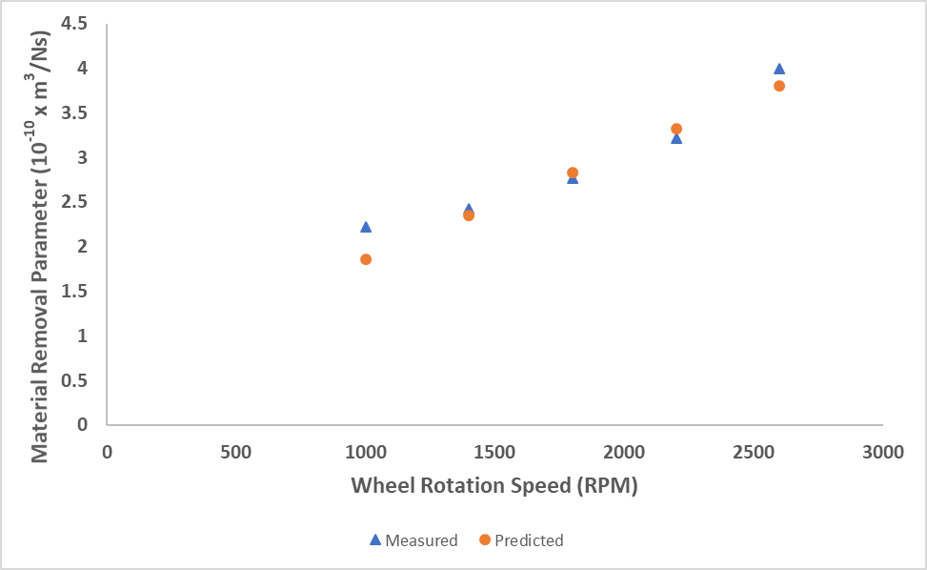

Figure 10: Comparison of measured and predicted material removal parameter values for infeed rate = 20 μm/s, wheel grade = I.

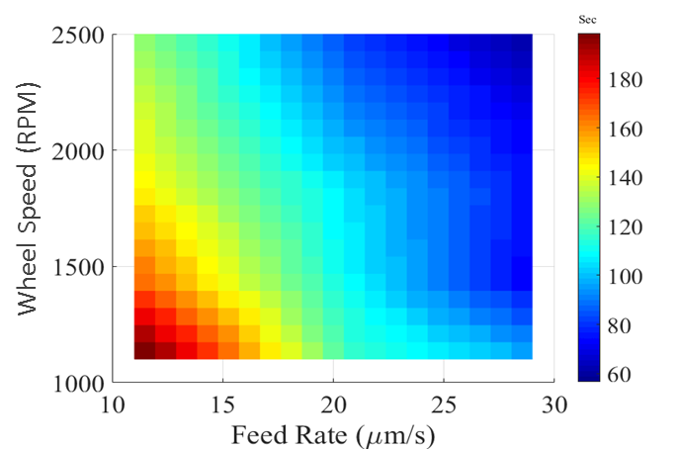

Figure 11: Face grinding cycle times for different infeed rates and wheel speeds.

Total face grinding cycle time is an important quantity as it determines the productivity of the process. Because of the robot’s lower stiffness, the total cycle time is expected to be higher than that obtained in specialized face grinding machines. In Figure 11 it can be clearly seen that as the wheel speed is increased at a fixed infeed rate, the total cycle time decreases. This is because a higher wheel speed corresponds to an increase in the material removal parameter, which lowers the system time constant. Consequently, the decrease in the time constant lowers the overall cycle time for the process. Figure 12 shows the variation in the system time constant with infeed rate and wheel speed. It is evident that at higher wheel speeds and infeed rates the system time constant decreases.

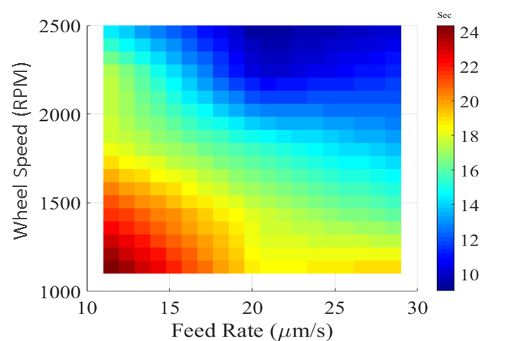

Figure 12: System time constants for different infeed rates and wheel speeds.

It is clear from these results that to face grind a fixed amount of material in minimum time, the infeed rate must be maximum. But from a practical standpoint, higher the infeed rate, greater the maximum normal force. Since the experimental setup in the present work is limited by the maximum load the rotary chuck motor can withstand (~70 N), the maximum permissible force is limited. Going to higher torque motors would mean increase in size and weight of the motor, which is again limited by the maximum payload capacity of the robot. Thus, a higher payload robot would be required to face grind at higher infeed rates.

In general, the robot Cartesian stiffness in the direction normal to the grinding wheel must be maximized and a practically achievable maximum wheel speed should be used. In the present work, the grinding wheel spindle for the experimental setup has no safety enclosure and thus it can’t be operated at higher speeds. However, this is a solvable problem from an industry application perspective. Finally, operating at higher infeed rates also requires that the grinding ratio *Gr* should be higher. This implies that a grinding wheel with higher hardness should be used.

# Conclusions

This paper presented an investigation of the cycle time behavior in a robotic face grinding process for bearing rings. The robot-workpiece interaction in the process was modeled as a function of the robot stiffness and face grinding process conditions to derive an analytical model of the face grinding process cycle time. The model parameters, namely the material removal parameter and system time constant, were determined from face grinding experiments and utilized to analyze the influence of face grinding process parameters such as wheel speed and infeed rate on the grinding cycle time and system time constant. The grinding process cycle time and system time constant were found to be inversely proportional to the robot Cartesian stiffness, robot feed rate and grinding wheel speed. Minimizing the cycle time requires the robotic face grinding process to be operated at the highest achievable wheel speed, using a robot with the highest possible Cartesian stiffness at the end-effector, and at the highest possible feed rate using a wheel of higher hardness. The process model discussed here can be utilized by practitioners to design a robotic face grinding system that meets their material removal rate and grinding cycle time needs.

# References

|  |  |
| --- | --- |
| [1] | P. Junskog, "Machine DG-500," KMT Grinding , [Online]. Available: https://www.kmtgrinding.com/machine/dg-500/. |
| [2] | J. Agapakis, J. Katz, J. Friedman and G. Epstein, "Vision-Aided Robotic Welding: An Approach and a Flexible Implementation," *The International Journal of Robotics Research,* vol. 9, no. 5, pp. 17-34, October 1990. |
| [3] | M. G. Her and H. Kazerooni, "Automated Robotic Deburring of Parts Using Compliance Control," *Journal of Dynamic Systems, Measurement, and Control,* vol. 113, no. 1, pp. 60-66, 1991. |
| [4] | "Yaskawa Paint Robots," [Online]. Available: https://www.motoman.com/robotic-painting. |
| [5] | "Automated deburring of metallic workpieces," [Online]. Available: https://www.kuka.com/en-in/technologies/process-technologies/2016/07/deburring. |
| [6] | I. Iglesias, M. Sebastian and J. Ares, "Overview of the state of robotic machining: Current and future potential," *Procedia Engineering,* vol. 132, pp. 911-917, 2015. |
| [7] | S. Matsuoka, K. Shimizu, N. Yamazaki and Y. Oki, "High-speed end milling of an articulated robot and its characteristics," *Journal of materials processing technology,* vol. 95, pp. 83-89, 1999. |
| [8] | B. Liu, F. Zhang , X. Qu and X. Shi, "A Rapid coordinate transformation method applied in industrial robot calibration based on characteristic line coincidence," *Sensors,* vol. 16, p. 239, 2016. |
| [9] | R. Arnold, "Cutting tools research: report of subcommittee on carbide tools: the mechanism of tool vibration in the cutting of steel," *Proceedings of the Institution of,* vol. 154, pp. 261-284, 1946. |
| [10] | I. Marinescu, M. P. Hitchiner, E. Uhlmann and W. B. Rowe, Handbook of machining with grinding wheels, Boca Raton, FL, USA: CRC Press, 2016. |
| [11] | R. S. Hahn and R. P. Lindsay, "PRINCIPLES OF GRINDING. 1. BASIC RELATIONSHIPS IN PRECISION GRINDING," *Machinery,* vol. 77, no. 7, p. 55, 1971. |
| [12] | R. S. Hahn and R. P. Lindsay, "PRINCIPLES OF GRINDING. 2. METAL REMOVAL PARAMETER," *Machinery,* vol. 77, no. 8, p. 33, 1971. |
| [13] | R. P. Lindsay, "The effect of parameter variations in precision grinding," *Journal of Engineering for Industry,* pp. 92(3), 683-693, 1970. |
| [14] | R. S. Hahn and R. P. Lindsay, "The influence of process variables on material removal, surface integrity, surface finish and vibration in grinding," *Advances in Machine Tool Design and Research,* pp. 95-117, 1969. |
| [15] | S. Malkin and S. Kannappan, "Effects of grain size and operating parameters on the mechanics of grinding," *J. Eng. Ind. Trans ASME Ser. B,* vol. 94, pp. 833-842, 1972. |
| [16] | G. K. Lal, "Forces in vertical surface grinding," *International Journal of Machine Tool Design and Research,* vol. 8, no. 1, pp. 33-43, 1968. |
| [17] | G. Srihari and G. K. Lal, "Mechanics of vertical surface grinding," *Journal of materials processing technology,* vol. 44, no. 1-2, pp. 14-28, 1994. |
| [18] | S. Malkin and C. Guo, Grinding technology: theory and application of machining with abrasives, Industrial Press Inc., 2008. |
| [19] | W. Wang , F. Liu, Z. Liu and C. Yun, "Prediction of depth of cut for robotic belt grinding," *The International Journal of Advanced Manufacturing Technology,* vol. 91, no. 1-4, pp. 699-708, 2017. |
| [20] | D. Zhu, S. Luo, L. Yang, W. Chen, S. Yan and H. Ding, "On energetic assessment of cutting mechanisms in robot-assisted belt grinding of titanium alloys," *Tribology International,* vol. 90, pp. 55-59, 2015. |
| [21] | X. Ren, M. Cabaravdic, X. Zhang and B. Kuhlenkotter, "A local process model for simulation of robotic belt grinding," *International Journal of Machine Tools and Manufacture,* vol. 47, no. 6, pp. 962-970, 2007. |
| [22] | S. Yixu, L. Hongbo and Y. Zehong, "An adaptive modeling method for a robot belt grinding process," *IEEE/ASME Transactions on Mechatronics,* vol. 17, no. 2, pp. 309-317, 2011. |
| [23] | X. Xie and L. Sun, "Force control based robotic grinding system and application," *2016 12th World Congress on Intelligent Control and Automation,* pp. 2552-2555, 2016. |
| [24] | Y. Sun, D. J. Giblin and K. Kazerounian, "Accurate robotic belt grinding of workpieces with complex geometries using relative calibration techniques," *Robotics and Computer-Integrated Manufacturing,* vol. 25, no. 1, pp. 204-210, 2009. |
| [25] | D. Zhu, X. Feng, X. Xu, Z. Yang, W. Li, S. Yan and H. Ding, "Robotic grinding of complex components: A step towards efficient and intelligent machining - challenges, solutions, and applications," *Robotics and Computer Integrated Manufacturing,* vol. 65, 2020. |
| [26] | M. Latifinavid, A. Donder and E. Konukseven, "High-performance parallel hexapod-robotic light abrasive grinding using real-time tool deflection compensation and constant resultant force control," *The International Journal of Advanced Manufacturing Technology,* vol. 96, pp. 3403-3416, 2018. |
| [27] | H. Huang, Z. M. Gong, X. Q. Chen and L. Zhou, "Robotic grinding and polishing for turbine-vane overhaul," *Journal of materials processing technology,* vol. 127, no. 2, pp. 140-145, 2002. |
| [28] | J. Craig, Introduction to robotics: mechanics and control, 3/E, Pearson Education India, 2009. |
| [29] | R. Hartenberg and J. Danavit, "Kinematic synthesis of linkages," McGraw-Hill, New York, 1964. |
| [30] | A. Olabi, M. Damak, R. Bearee, O. Gibaru and S. Leleu, "Improving the accuracy of industrial robots by offline compensation of joints errors," in *2012 IEEE International Conference on Industrial Technology*, 2012. |
| [31] | K. B. Kaldestad, I. Tyapin and G. Hovland, "Robotic face milling path correction and vibration reduction," *2015 IEEE International Conference on Advanced Intelligent Mechatronics (AIM),* pp. 543-548, 2015. |